|  |
| --- |
| <Sydney Airbnb Data Analysis Tool> Executive Summary |
| Arjan Dangol (s5295636) | Jamil Deris (s5291506) | Tanish Dhir (s5287914)2810ICT / 7810ICT Software TechnologiesOctober 8, 2023 |

# Abstract

A 100 to 150 word executive summary of your findings. Do this last.

Based on the testing

# Introduction

Explains the purpose of this report. Include the date range covered, and the different analysis tasks performed.

The purpose of this report is to demonstrate working of Sydney Airbnb Dataset Analysis Tool. The date range (YYYY-MM-DD) covered is the from 2018-10-08 to 2019-10-08 i.e., 12-month period. Various analysis tasks were performed in that time frame such as:

- Making sure the tool is working properly

- Testing using pytest, to make sure every input is covered

- Made user manual based on use cases

- Updated use cases according to the program

# **Analysis 1 Room Listing Function**

The following are results of using Listings function. This function takes users on the page where they can choose a suburb and select a date range. Then clicking on search the program will generate a table with listing id as ‘id’, ‘suburb’, ‘description, ‘name’, ‘street’, and ‘zipcode’.

Test 1:

# **Analysis 2 Price Distribution Chart Function**

Below are results of using Price Chart function. This function takes users on the page where they select a date range. Then clicking on CreateChart the program will generate a histogram chart with the ‘Average Price’ on the Xlabel and ‘Frequency’ on the Ylabel showing the distribution of prices by listing id.

Test 1:

# **Analysis 3 User Specific Room Listing Function**

Following are results of using User Specific function. This function takes users on the page where they select a date range as well as enter keywords in textbox like spa, pool and other relevant keywords. Then clicking on search the program will generate a table with listing id of rooms based on user entered keywords. If no rooms are there, empty table is shown.

Test 1: Here the keyword used is pool with date range: start_date (2018-10-08) and end_date (2019-10-08)

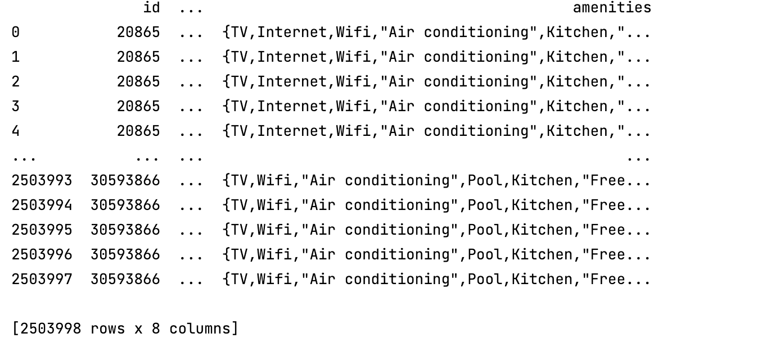

This screenshot is the table data shown in the run console. As the data row was high in number, it didn’t load in the software GUI.

# **Analysis 4 Reviews Analysis Function**

In this section, test is based on review analysis function. Users need to click on reviews button which will take them to reviews page. They need to select a date range and click on search button. The program displays review chart based on listing id.

Test 1:

# **Analysis 5 Room Usage Analysis Function**

Below is the analysis of room usage function of the program. Users need to click on RoomUsage button. Then select a date range and click on search. The program displays a chart with room usage based on listing id.

Test1:

